http://www.3-7Class.org.nz
http://groups.google.com/group/3-7Class
http://www.facebook.com/3.7
OWNERS’ ASSOCIATION
NEWSLETTER APRIL 2012
Nationals – Derek Scott Maintains the Magic
Takapuna, April 6, 7, 8. Good sailing for 18 entrants too!

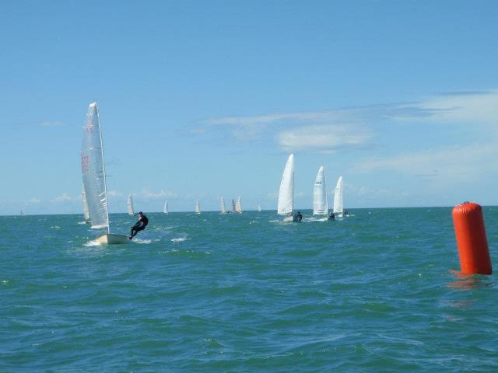
Race 1: Derek has already seized the lead as we approach the end of the triangle.
Derek looked to be a sure winner after this first race… but both Lance O’Connell (guilty) and Mark O’Brien (not guilty) had gone back at the start when the individual recall flag went up.
We then saw a titanic struggle between two champions: Mark O’Brien took out the next two races, and the contest was wide open. (Mark won convincingly back in 2005 and 2006. He then left NZ, and this was his first Nationals since he returned.) These two outclassed the rest of us until Race 5, when Lance O’Connell suddenly re-discovered his winning ways, and rose to their level.
In Race 1, Mark had worked his way back up to 6th, but this meant he had to count all other placings. Derek was so consistent overall that he dropped a 3rd, and counted only 1st’s and 2nd’s. Mark won 1 more race than Derek, but Derek’s classy over-takings in Races 4 and 6 gave him the vital edge. By Race 7 Derek could have counted his 3rd and still won. A clear victory.
Under-21 Champion was again Andrew Clarke. Gear failure put Andrew out of the last race, but he was able to drop that performance and still out-point Katie de Lange by just 3 points. In the only light-air race (Race 4) Katie beat Andrew by 8 places, but her lack of time on the water in choppy, trapezing conditions gave Andrew the edge overall. Katie did, however, sail through all races with no placing worse than 13th, and was the deserving winner of the Ladies’ Prize.
Us old guys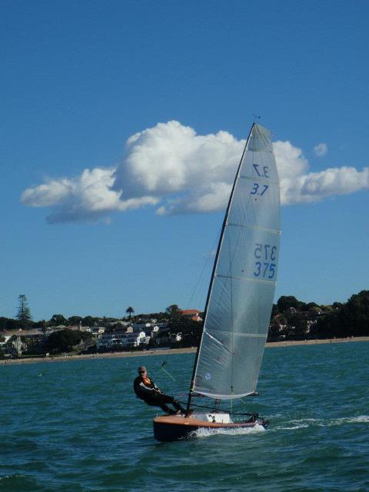….
David Cook (Wellington) was the oldest entrant (at least 66, maybe 67?), and said he greatly enjoyed the sailing, despite little time on the water this season.
Veterans’ Division (45 yrs old and over) was very closely-contested. All who finished between third and eighth were eligible. Mike Jones was 3rd on 27 points: Lance O’Connell and Phil Ash were tied on 28 points; I was 6th on 30 points - 4 sailors within 3 points of one another! (Personally, I think the age limit should be raised from 45 to 65, to give me a fair go…) Then there were Kevin Holland (40) and Chris Hawkins (42). (Points, not age.)
SCANDAL AND BLAME !!
The two Sunday races were great sailing: shifty gusts peaking just over 20 knots, which finally gave us glorious trapeze-reaching. The courses had always offered this, but winds of usually less than 15 knots had mostly resulted in stacking reaches for the first two days, except for the skinny, (who still struggled to trapeze properly.. or so I say. I mostly kept up with them by just stacking.)
Then Sunday: sunny, brilliant breeze, throw away power upwind and blatt wildly down some of the reaches. I thought Sunday one of the better sailing days that we have had in many Nationals.
Only 12 tough boats and skippers remained for the final race. Phil Ash has to be unlucky man of the contest.
Phil sailed a pretty good final race – and finished with 2 boats between him and Mike Jones. This should have given Phil 3rd overall, as well as the Veterans’ Cup. But…
Just as Phil finished, the skipper of the following boat accidentally dropped his tiller extension. His boat was sailing fast and free, and immediately rounded up, straight into the path the next boat. Neither could avoid collision: both went over, got entangled, and because of this, Phil no longer had anyone between him and Mike Jones. Mike therefore beat Phil for 3rd place overall, and the Veterans’ Cup.
This was tough on Phil, but that is how sailing can turn out… All the points were close anyway.. Mike has sailed very well this season, and he sailed well enough to be in that position when it arose. Congratulations to Mike Jones. His name will look good on the Veterans’ Cup. Sailing has an element of luck, and we simply have to live with it.
GUILT: Independent Class Secretary (Chris Mitchell, currently in Valencia, Spain) has considered the situation, and his verdict is conclusive. We should not name the skipper who dropped his tiller extension, because he is not guilty – he should never have been put in that position. There is only one guilty party, and that is….
Bad boy Lance O’Connell. !!
It is all his fault, because if Lance had sailed (as he ought to have!) right from the beginning the way he did in Races 5, 6, 7, nobody else would have been anywhere near 3rd place or taking the Veterans’ Cup. Lance would easily have taken both.
So Lance is the culprit who caused this fluctuation in fortunes, and, personally, I think Cheryl should consider serious disciplinary measures – something like a spanking, maybe.

Thanks to Takapuna and Race Officer Dave West for a great contest.

2012 3.7 National Championships

Takapuna Boating Club

Results as of 15.08 on 8 April

Overall
Sailed: 7, Discards: 1, To count: 6, Entries: 18, Scoring system: Appendix A
Rank | Fleet | Sail No | Club | Helm Name | R1 | R2 | R3 | R4 | R5 | R6 | R7 | Total | Nett
1st | 3.7 | 372 |  | Derek Scott | 1.0 | 2.0 | 2.0 | 1.0 | (3.0) | 1.0 | 2.0 | 12.0 | 9.0
2nd | 3.7 | 176 |  | Mark O'Brien | (6.0) | 1.0 | 1.0 | 3.0 | 1.0 | 4.0 | 1.0 | 17.0 | 11.0
3rd | 3.7 | 188 |  | Mike Jones | 2.0 | 3.0 | (8.0) | 5.0 | 7.0 | 3.0 | 7.0 | 35.0 | 27.0
4th | 3.7 | 265 |  | Lance O'Connell | (10.0) | 7.0 | 5.0 | 9.0 | 2.0 | 2.0 | 3.0 | 38.0 | 28.0
5th | 3.7 | 111 |  | Phil Ash | 3.0 | 5.0 | 3.0 | (6.0) | 6.0 | 5.0 | 6.0 | 34.0 | 28.0
6th | 3.7 | 308 |  | John Elliott | 4.0 | 4.0 | 6.0 | 7.0 | 4.0 | (9.0) | 5.0 | 39.0 | 30.0
7th | 3.7 | 377 |  | Kevin Holland | 9.0 | 8.0 | 4.0 | 2.0 | 8.0 | (10.0) | 9.0 | 50.0 | 40.0
8th | 3.7 | 364 |  | Chris Hawkins | 7.0 | (19.0 OCS) | 10.0 | 10.0 | 5.0 | 6.0 | 4.0 | 61.0 | 42.0
9th | 3.7 | 382 |  | Ryan Houston | 5.0 | 10.0 | 12.0 | 8.0 | (19.0 DNF) | 7.0 | 8.0 | 69.0 | 50.0
10th | 3.7 | 399 |  | Jonathan McMullan | (13.0) | 9.0 | 7.0 | 11.0 | 9.0 | 8.0 | 10.0 | 67.0 | 54.0
11th | 3.7 | 187 |  | Andrew Clarke | 8.0 | 6.0 | 9.0 | 12.0 | 11.0 | 11.0 | (19.0 DNS) | 76.0 | 57.0
12th | 3.7 | 381 |  | Katie de Lange | 11.0 | 11.0 | 11.0 | 4.0 | 10.0 | (13.0) | 13.0 | 73.0 | 60.0
13th | 3.7 | 393 |  | Mark Mc Minn | (15.0) | 14.0 | 13.0 | 13.0 | 12.0 | 14.0 | 11.0 | 92.0 | 77.0
14th | 3.7 | 244 |  | Matt Hunter | (14.0) | 12.0 | 14.0 | 14.0 | 14.0 | 12.0 | 12.0 | 92.0 | 78.0
15th | 3.7 | 375 |  | David Cook | 16.0 | 15.0 | (19.0 DNF) | 15.0 | 13.0 | 19.0 DNF | 19.0 DNS | 116.0 | 97.0
16th | 3.7 | 87 |  | Benny Butcher | 12.0 | 13.0 | (19.0 RAF) | 19.0 RAF | 19.0 DNS | 19.0 DNF | 19.0 DNS | 120.0 | 101.0
17th | 3.7 | 108 |  | William Wright | (19.0 DNF) | 19.0 DNF | 16.0 | 17.0 | 15.0 | 19.0 DNF | 19.0 DNS | 124.0 | 105.0
18th | 3.7 | 321 |  | Robyn de Lange | (19.0 DNF) | 19.0 DNS | 15.0 | 16.0 | 19.0 DNF | 19.0 DNS | 19.0 DNS | 126.0 | 107.0

Can of Contest: many qualifiers, but the two guys we awarded the beer-cans to gave them back because they did not drink beer, so either Chris Hawkins (efficient capsizes) or Andrew Clark (most inelegant capsizes) took the cans – I cannot now remember. The Potty was not awarded, because Kevin Holland had forgotten to bring it up from Christchurch, where (he kidded us) it had been put to good use during the Portaloo shortage. Forgetting to bring the Potty after remembering all the other things he had to bring is an act that qualifies Kevin for retention of the Potty.
FROM THE AGM: Tim Griffiths has stood down from Committee – thanks Tim for your email input over the last few years. Officers: John Elliott (Pres.); Chris Mitchell (Sec.); Committee: Jonathon McMullan; Andrew Clarke; Phil Ash; Gavin Auld; Chris Hawkins; Lance O’Connell; Kevin Holland; Derek Scott; Demian Dixon; David Cook. Chief Measurer: Kevin Holland.
Less Restricted Sail was the topic that caused the longest discussion. Benny’s motion was lost because most felt it was too soon and sudden to move the class away from the current concept, which is close to one-design. (Benny had largely expected this.) However, Benny had stopped formally racing in the Contest on Saturday morning when the wind lightened, and, with his big shape sail, had sailed the course with us (without running interference).
Interesting. This was Benny’s first use of the sail, and the boat may have needed re-tuning to improve balance and speed. My impression was that the lighter the wind, the less difference the big sail made in terms of boat speed: Benny still struggled with his muscular bodyweight! Moderate breezes did help Benny get out on the wire as early as lighter guys, but only on a few occasions did I think he was going faster than the front guys were going with normal sails. I guess one cannot expect a difference as big as the No. 1 rig on a 12-footer makes in light airs, because a 12-footer uses a much longer mast as well as huge sails.. Sticking with a 6150mm mast means the sail cannot make a huge difference. Benny’s boat did, however, look good, which many acknowledged. While not wanting to change the class rules, many are keen to see how the big sail can be developed and used, just as a point of interest. (Sorry – the photos I have available are from Day 1 only, when Benny was not using the big sail. You can see a picture comparison to the normal sail shape on the 3-7 Facebook page.)
Cost of Plans: It was decided to leave the plans at their current low price, but to raise the cost of being issued an official sail number to $NZ50. With digital plans, etc in the offing, it was felt that this was a better way to protect the control of the class, and that it would allow us leeway to negotiate with a possible UK Owners’ Association. (I have now sent 5 sets of plans to the UK in recent times.)
OTHER NEWS
The Waikato-Thames Champs were held in light winds (but some trapezing) on Lake Ngaroto the weekend before the Nationals. Attending were only Mike Jones, Lance O’Connell, Phil Ash, and John Elliott. Only 4, but a pretty good fleet: these guys went on to take 3rd, 4th, 5th, and 6th at the Nationals. Close racing: 3 of us tied on points after 7 races (worst dropped). John Elliott won after the most convoluted countback possible… don’t ask! John Elliott 2, 4, 1, 1, 4, 3, 3 (High points scoring here. 4 = first over the line.) Lance O’Connell 4, 2, 4, 3, 3, 1, 1 Phil Ash 3, 3, 3, 2, 2, 4, 2 Mike Jones 1, 1, 1, 2, 4, 1, 4
Idyllic club, camping and launching area, lovely dinner put on Sat night, good racing… WHERE ARE THE REST OF YOU ??
Hoping to see some of you at the Auckland Champs at Takapuna this weekend! (April 21, 22) Enough for this newsletter – another one soon.
John Elliott

