http://www.3-7Class.org.nz
http://groups.google.com/group/3-7Class
http://www.facebook.com/3.7
OWNERS’ ASSOCIATION
NEWSLETTER February 2013
Nationals –
The O’Brien Reassertion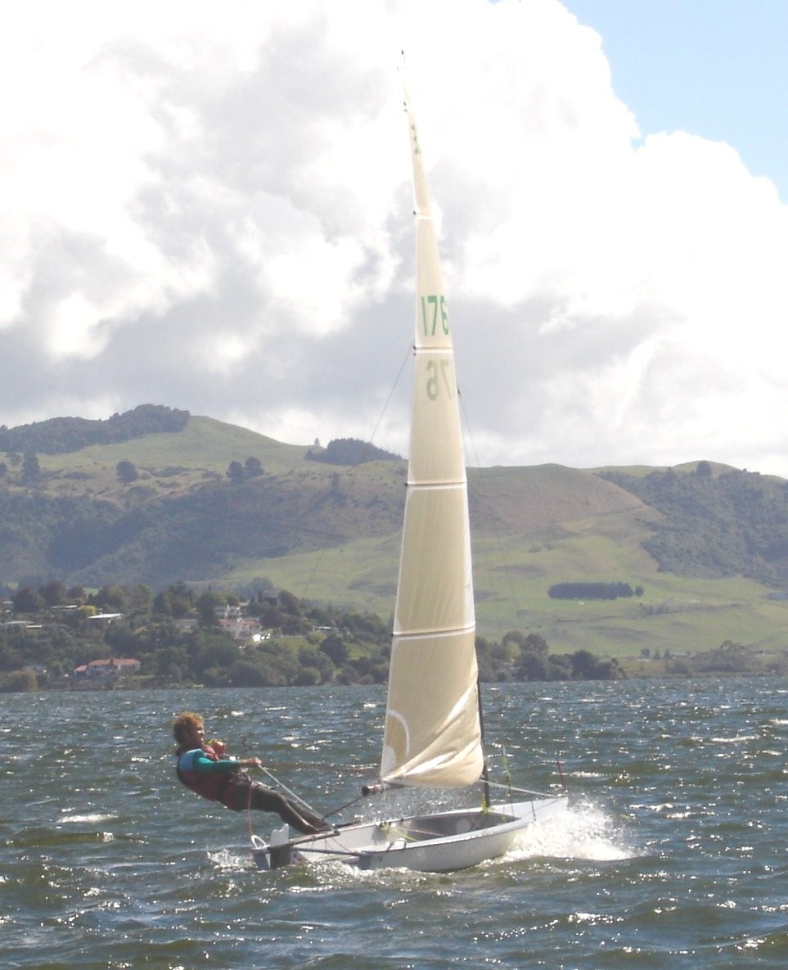
Is this photo familiar? It is Mark O’Brien cleaning us up in Rotorua 2005. He did it again at Whitianga 2006. After some years overseas, he came back, and pushed Derek Scott hard last year. Derek made him settle for 2nd that time.
This Year: Mark ruled the contest. 4 straight wins, based on Top Boat Speed, Top Tactics, and Top Whatever. Mark has it all. He led at every mark for several races.
And why that photo? Two reasons: 1) I have no photos of this year’s contest.
2) No matter. That is exactly the boat that Mark used this year. No new sail, no new mast, no new anything (except maybe aftershave). Guys who have bought or made new gear (and that includes me) since 2006 have just had a lesson about something.
After 4 straight wins, Mark had only to finish reasonably well up, and he may have changed his tactics accordingly...
GEAR Mark has a one-off C-Tech mast – a discarded 12-footer skiff mast for high winds. It is skinny, on the stiff side, and about 3 inches shorter than our standard mast. The 3 inches are missing at the bottom. (!) Funnily enough, I suspect that to be an advantage. To my mind, all the hoo-ha about getting your rig high applies only in marginal trapezing conditions, and once you are fully trapezing and spilling power, it makes far more sense to lower your entire rig.
Mark’s sail is from Fyfe, made by Chris Skinner, but I remember that Mark and Chris put some time into altering the sail to suit the mast back in 2005. It worked, and it now seems that while both Derek Scott (Norths) and Doyles (look at Lance O’Connell’s sail) may since have equalled that 2005 combo, nobody has surpassed it.
Mark’s sail just sitting on his mast is a thing of beauty, for those who like that sort of thing...
Derek Scott was clear second, and dominated the last two races. (Who can be sure that Mark eased off?) By Race 6 Derek was also a clear step ahead of the rest of us, and he is obviously not at the end of his chain of successes! Beautiful mast/sail combo as well – maybe because he is a top sailmaker?
Paul Snow-Hansen – a surprise entrant, casually jumped into a borrowed boat, and showed us how a young Olympic campaigner can perform near-miracles. One race to get the feel, and then three 2nd placings! The boat is No 389, Recidivist, Tim Willetts’ final masterpiece before he moved on to big trimarans. The boat went into obscurity for a few years, but is now advertised for sale, and, when sailed well, obviously goes like a rocket. Paul was clear 3rd overall.

RESULTS
2013 NZ 3.7 Nationals Manly Sailing Club Farr 3.7 Class

Sailed: 6, Discards: 1, To count: 5, Entries: 16, Scoring system: Appendix A

Rank SailNo Club Helm Name R1 R2 R3 R4 R5 R6 Total Nett

1st 176 Hamilton Yacht Club Mark O'Brien 1.0 1.0 1.0 1.0 (4.0) 3.0 11.0 7.0
2nd 372 NPCL Derek Scott (4.0) 3.0 3.0 2.0 1.0 1.0 14.0 10.0
3rd 389 Wakatere Paul Snow-Hansen 7.0 2.0 2.0 4.0 (8.0) 2.0 25.0 17.0
4th 265 Rotorua Lance O'Connell 2.0 (7.0) 4.0 7.0 5.0 5.0 30.0 23.0
5th 111 Manly Sailing Club Phil Ash 3.0 6.0 5.0 (8.0) 2.0 8.0 32.0 24.0
6th 188 Manly Sailing Club Mike Jones 5.0 5.0 (6.0) 6.0 3.0 6.0 31.0 25.0
7th 88 Wakatere Derek Snow 9.0 4.0 11.0 3.0 10.0 (13.0) 50.0 37.0
8th 388 Wakatere Kate Ellingham 10.0 (11.0) 8.0 5.0 7.0 9.0 50.0 39.0
9th 308 Hamilton Yacht Club John Elliott 8.0 10.0 7.0 12.0 (13.0) 4.0 54.0 41.0
10th 187 BOIYC Andrew Clarke 6.0 8.0 10.0 9.0 (11.0) 10.0 54.0 43.0
11th 364 Wakatere Chris Hawkins 11.0 9.0 9.0 (14.0) 9.0 11.0 63.0 49.0
12th 399 Hamilton Yacht Club Jonathon McMullan (15.0) 15.0 14.0 10.0 6.0 7.0 67.0 52.0
13th 229 Manly Sailing Club Oliver Hawkley 12.0 12.0 12.0 13.0 (14.0) 12.0 75.0 61.0
14th 371 Manly Sailing Club Matthew Lovett 14.0 13.0 13.0 11.0 (15.0) 14.0 80.0 65.0
15th 203 Manly Sailing Club Luke Heslewood 13.0 (16.0) 15.0 15.0 12.0 16.0 87.0 71.0
16th 375 Titahi Bay David Cook 16.0 14.0 (17.0DNS)16.0 16.0 15.0 94.0 77.0

Veterans’ Cup went to Lance O’Connell, who also took a good 4th overall. He narrowly squeezed out local stars Mike Jones and Phil Ash, whose improving performances over the last few years have made things tough for us real veterans in their mid-60’s! Lance now has his name on that cup 11 times – one short of John Elliott’s record 12. But Lance still has the form to pass that mark..
Under-21 Cup again went to Andrew Clarke, who is performing well with a sail like Lance’s on a Willetts wing mast – a powerful combo.
Can of the Contest as well as the Potty (back from the South Island) went to Paul Snow-Hansen. In a fairly light-weather contest, Paul had a good lead early in Race 3, but stopped for a difficult-to-explain swim part-way up the next windward leg....
Paul’s Dad (Derek Snow) took a bottle of Bubbly for an outstanding performance in Race 4, and other bottles went to Andrew Clarke (Race 1), Kate Ellingham (Race 4), Jonathon McMullan (Race 5), Luke Heslewood (Race 5) and John Elliott (Race 6).
Kate Ellingham’s Ladies’ prize was deserved, if not hotly-contested. Our fleet of 16 was down a little because of apologies, two of which were other ladies. Robyn de Lange was coming, but then committed to keelboat team-racing (like sister Katie) and could not make it. Naomi Paine was taken out, along with dearly-beloved husband Mark McMinn, by Chris Skinner’s wedding... (congrats to Chris, but poor timing!) Lastly, Kevin Holland had booked a ferry passage across Cook Strait, but fingers broken last winter failed to heal, and he had to undergo surgery instead of coming to Manly.
So under better circumstances our fleet of 16 would have been 20 – not so bad.

Conditions: beautifully fine, but light and shifty winds meant a lot of waiting between races, with quite an amount of crouching/stacking upwind at times, but also occasional full, consistent trapezing.
Many thanks to the Manly Club and the Zephyr Class for inviting us there after we found we could not get the Easter venue we wanted!

We now have to work out what to do for the rest of the season, including where to have our North Island Champs.
Tauranga Regatta is too close: this Saturday, straight after Manly, meaning we will get very few boats willing to attend..
Email consultations will follow..
ANNUAL GENERAL MEETING was held quickly. Same Officers, Committee and subs for next season. The President gave special THANKS to Chief Measurer Kevin Holland for the big work he has done on new plans and AutoCAD files, and also absentee Secretary Chris Mitchell for his contributions on the website, facilitating PayPal for purchase of plans, subs, etc.
Hope to see you sailing soon – watch your emails!

John Elliott

